**Jenkins Issues**

1. Script running fine using maven (Eclipse) but while running using Jenkins, unable to launch browser.

**First Solution:**

1. Open Jenkins service (Using command services.msc) .
2. Click on Log On tab and then select the “allow service to interact with desktop” check box as shown in below mentioned screenshot.
3. Click on apply and ok button.
4. Last but not least restart the Jenkins service.

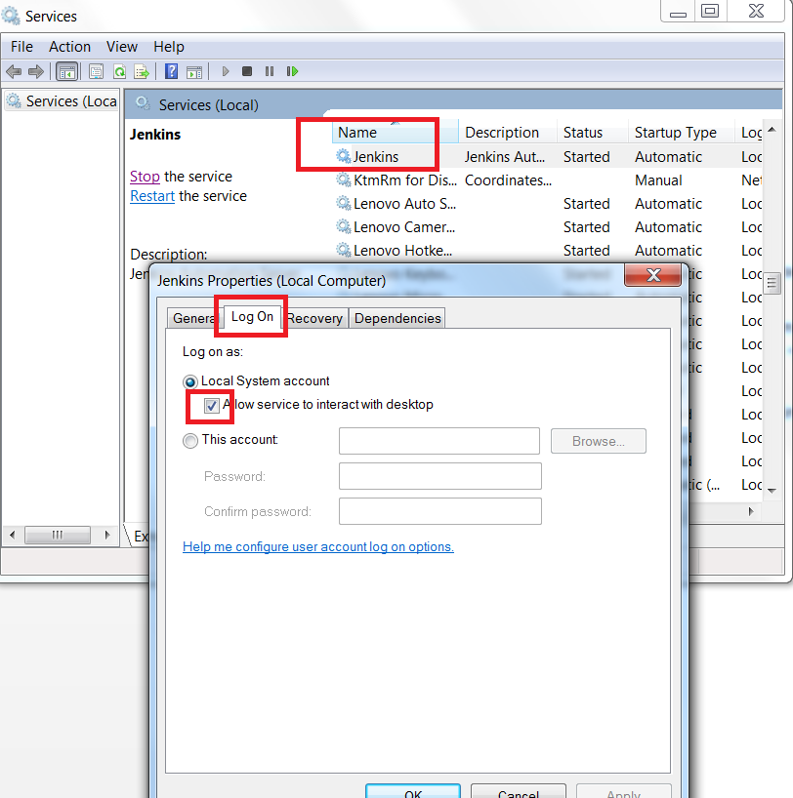

Second Solution : set Jenkins as a process ( run Jenkins from command prompt) , not a Service

1. hdhdh